**EXPERIMENT NO. 13 (Group B)**

**Aim:**  Write a program using piezo element and use it to play a tune after someone knocks

* **Outcome:** Connectivity, understand how piezo element work
* **Hardware Requirement:** Arduino Board, Piezo electric disc, 1 resistor.
* **Software Requirement**: Arduino IDE

## Theory:

The problem statement shows you how to use a [**Piezo element**](http://en.wikipedia.org/wiki/Piezoelectric_sensor) to detect vibration, in this case, a knock on a door, table, or other solid surface.

A **piezo** is an electronic device that generates a voltage when it's physically deformed by a vibration, sound wave, or mechanical strain. Similarly, when you put a voltage across a piezo, it vibrates and creates a tone. Piezos can be used both to play tones and to detect tones.

The sketch reads the piezo output using the analogRead()  command, encoding the voltage range from 0 to 5 volts to a numerical range from 0 to 1023 in a process referred to as *analog-to-digital conversion*, or *ADC*.If the sensors output is stronger than a certain threshold, your board will send the string "Knock!" to the computer over the serial port.

Open the serial monitor to see this text.\

**Connection:**

The hardware a part of this project is quite simple and easy to place together. First of all, make the connections for the force sensor with the Arduino. The connections for the force sensor with the Arduino given in the above circuit diagram.

The force sensor we used here has size 2 inch. force sensor has two pins one is connected to the GND pin of an Arduino and another pin is connected to the digital pin of an Arduino using the voltage divider across this pin.

Connect the one terminal of force sensor to the GND of an Arduino.

Connect the other terminal of FSR to resistor for creating the voltage divider.

Connect the voltage divider output is connected to the analog input pin A0 of an Arduino.

Connect the piezo electric disk with two connections

(+) Connection connected to the digital pin with register

(-) Connection connected to the ground

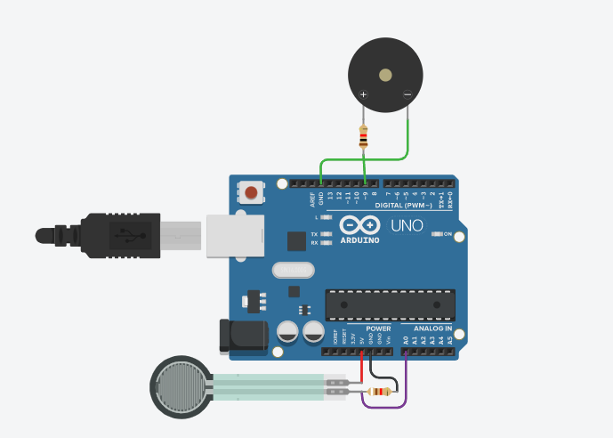

------------------------------------------------------------------------------------------------------------------------

Conclusion: -

-------------------------------------------------------------------------------------------------------------------------